Practice Assignment #2 – Inheritance

- TrailBot
Extend the Robot class to create a TrailBot. A TrailBot can leave behind a trail of "crumbs" (Thing objects) when it moves. Arrange for instances of TrailBots to always start with 100 Things in their backpacks.

  - TrailBots should have a method called trailMove( ) that leaves a "crumb" on the current intersection and moves forward to the next intersection.

  - Create a program to test your TrailBot.

- StairMaster
Create a program that will move all the Things from the first staircase to the second staircase. This requires a StairMaster that inherits from the Robot class, and has the methods turnRight( ), stepUp ( ) and stepDown ( ) to help negotiate the stairs. This program will use two StairMasters to complete the relay. The first StairMaster should collect all the Things and bring them to the second StairMaster, which will then place them on the second set of stairs.
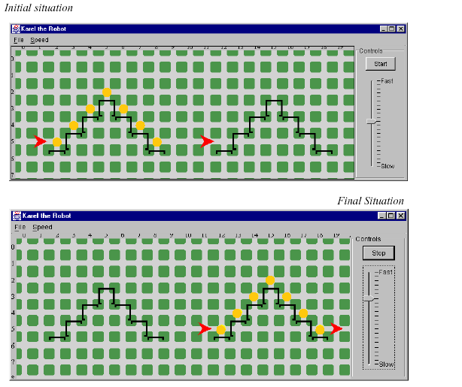

- SoccerPlayer
Extend the Robot class to create the SoccerPlayer class with the following services:
advance ( ) – moves the player forward one intersection
advanceLeft ( ) – moves the player diagonally to the left one intersection
advanceRight ( ) – moves the player diagonally to the right one intersection
advance(int distance) - moves the player forward distance intersections
advanceLeft (int distance) – moves the player diagonally to the left distance intersections
advanceRight (int distance ) – moves the player diagonally to the right distance intersections

*All advance methods should cause the Robot to pick up the ball (a Thing) before moving and put it down after moving.

*For each advance method, there should be a similar move method that moves the SoccerPlayer in the same manner without the ball

Create a SoccerField class that extends the city class and looks like the following diagram:
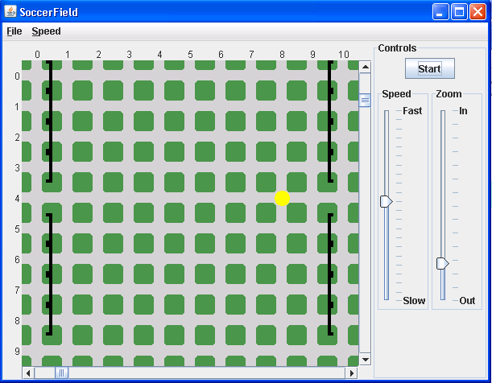

Test your classes by running a soccer practice (moving players across the field).

